|  |
| --- |
| Ventana Deporte |

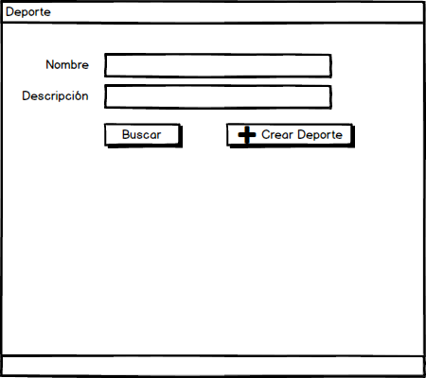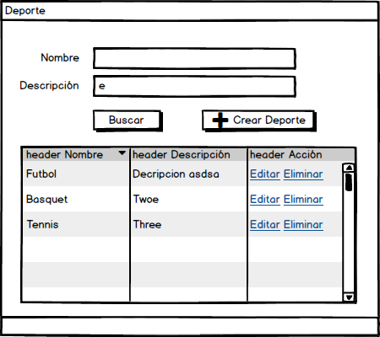

|  |
| --- |
| Ventana Alta Deporte |

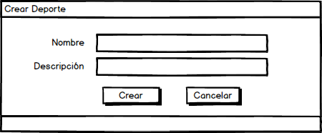

|  |
| --- |
| Ventana Modificar Deporte |

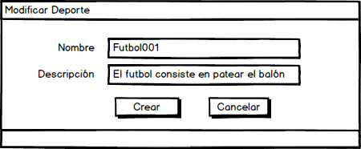

|  |
| --- |
| Ventana Baja Deporte |

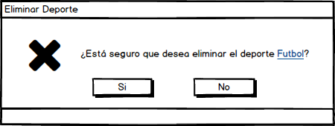

|  |
| --- |
| Acciones de botones: |







